STOP DIABETES
Diabetes occur when the level of sugar (glucose) in the blood becomes higher than the normal. This happens when the body can’ make the hormone insulin or stops responding to it.
Untreated it can lead to amputations, blindness, kidney illness, stroke, and heart disease. But it can be reversed with lifestyle changes. The standard test for diabetes involves checking for glucose in urine.
If it is found a special blood test- Glycated Haemoglobin –is used to check the level of sugar in your blood.
Watch out for the 4T’s:
TOILET: Going to toilet a lot, or a previously dry child wetting the bed.
THIRST: Being really thirsty; unable to quench your thirst.
TIRED: More than usual.
THINNER: Unexpected weight loss.
OTHER WARNING SIGNS-
- Getting up in the night to use the toilet.
- Dry mouth.
- Blurred vision.
- Recurrent infections.
- Itching around genitals.
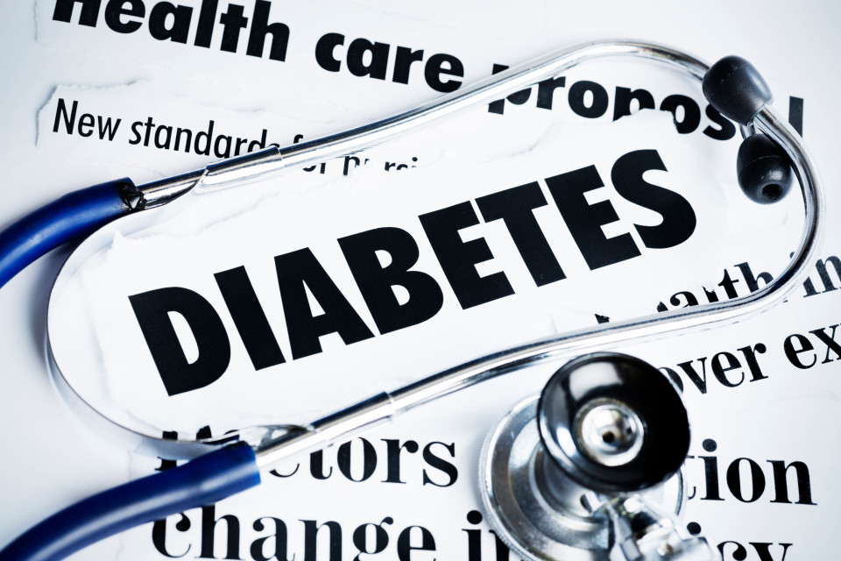
LIFESTYLE CHANGES HELP:
Whether you have pre-diabetes or the condition is established, making alterations to your routine can still lower the chance of developing some of the nastier complications.
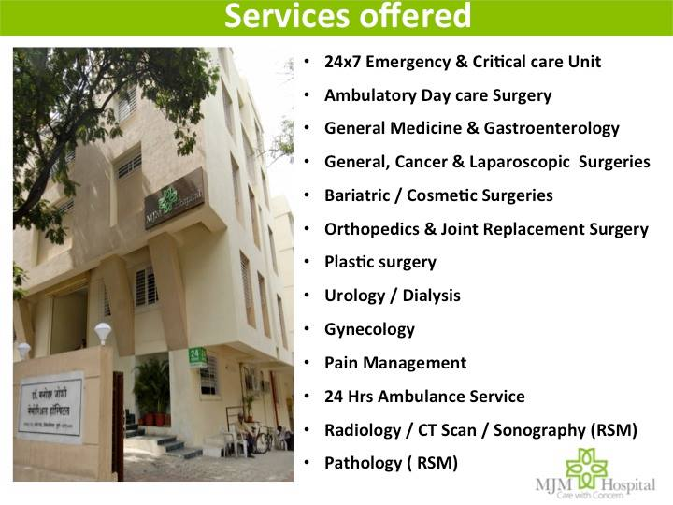
MJM HOSPITAL runs “DIABETES CLINIC” in their hospital at ghole road, Pune. The hospital has special programs to help patients in preventing diabetes.
For more details contact: 09769337236.

